Module 5:

Configuring Advanced Task Information

Contents

Module Overview 1

Lesson 1: Working with Task Constraints 2

What are Constraints? 3

Constraint Types 4

Actions That Create Automatic Constraints 6

Effects of Constraints 9

Practice: Working with Task Constraints 12

Lesson 2: Advanced Task Management 13

Task Deadlines 14

Using the Task Inspector 18

Using Task Form Views 22

Adding Notes to Tasks 25

Applying Task Calendars 27

Splitting Tasks 29

Changing the Start Date of a Project 32

Practice: Working with Advanced Tasks 34

Summary 35

5

.

# Module Overview



Once the project schedule has been created, it will need refining. Project 2010 provides multiple methods to refine the scheduling of a project. During this module we will describe information about the tools available and the best practices regarding the use of the functions.

After completing this module, you will be able to:

1. Work with Task Constraints
2. Understand what Constraints are and what types of constraints are available?
3. Create Automatic Constraints
4. Understand errors caused by Constraints
5. Establish task deadlines
6. Use the Task Inspector
7. Create task calendars
8. Use Task Form Views
9. Create Project Schedule Notes
10. Split Tasks
11. Change the start date of a project

# Lesson 1: Working with Task Constraints



Project schedule constraints are used to adjust the project schedule in an effort to balance the freedoms and limitations of project delivery. Understanding how Project 2010 interprets constraint types and the affect they will have on the scheduling of a project will help avoid problems during the execution and tracking phase of the project.

In this lesson we will discuss:

* What are constraints and when to use them
* Know the types of constraints available in Project 2010
* Why constraints should be used sparingly
* Issues that constraints might cause

## What are Constraints?



Constraints are defined as conditions upon which a project must be managed against which can negatively affect budget, quality, schedule and scope.

Some typical constraints might include a lack of:

* Money
* Skilled resources
* Requirements for the project
* Equipment
* Management support
* Time

Even though the above constraints are important to the success of a project, Project 2010 cannot account for these constraints. However, the constraints Project 2010 can help you with are dates.

Tasks may require a target date or start at a specific date, end at a specific date, or require scheduling at the beginning or ending of a timeframe.

Date constraints can be used to refine the project schedule when greater control is needed for specific tasks start or finish dates. Using date constraints, however, will also remove flexibility from the schedule. It is for this reason that the use of constraints be kept to a minimum. Some of the date constraints are more flexiable than others available. The flexible constraints will be the most beneficial during scheduling.

NOTE: *Manual Scheduled tasks can not use contraints. They are used for Automatically Scheduled tasks only.*

## Constraint Types



Constraints are used when a task must be scheduled with a specific date in mind or within a specific time period. When setting constraints, the following pieces of information must be known:

* Constraint type
* Date for the constraint

There are 8 constraint types available in the Project 2010 and all are date dependent:

1. **As Soon As Possible (ASAP)** - default constraint applied to all tasks when a project is scheduled from the project start date. Tasks will be scheduled as early as possible within a timeframe.
2. **As Late As Possible (ALAP)** - default constraint applied to tasks when a project is scheduled from the finish date of the project. Tasks will be scheduled as late as possible within a timeframe.
3. **Finish No Earlier Than (FNET) -** applied to a task that must finish no earlier than a specified date. The constraint date will be applied to the finish date of the task and the task will move forward in time to the date specified for this constraint.
4. **Finish No Later Than (FNLT) -** applied to a task that must finish no later than a specified date. During tracking, tasks will move forward in the schedule. Tasks with Finish No Later Than constraints will move forward and stop at the constraint date.
5. **Start No Earlier Than (SNET) -** applied to a task that must start no earlier than a specified date. The constraint date will be applied to the start date of the task and the task will move forward in time to the date specified for this constraint.
6. **Start No Later Than (SNLT) -** applied to a task that must be started by a specified date. During tracking, tasks will move forward in the schedule. Tasks with a Start No Later Than constraints will move forward and stop at the constraint date.
7. **Must Start On –** applied when a task has a hard start date. The task will move to the constraint date and is fixed on that date.
8. **Must Finish On -** applied when a task has a hard finish date. The task will move to the constraint date and is fixed on that date.

**To create a task constraint:**

* Double click on a **task** to open the Task Information dialog box
* Click **Advanced** tab
* Click **Down Arrow** to the right of Constraint type and select a constraint type
* Click **Down Arrow** to the right of Constraint date and assign a date for the constraint
* Click **OK**

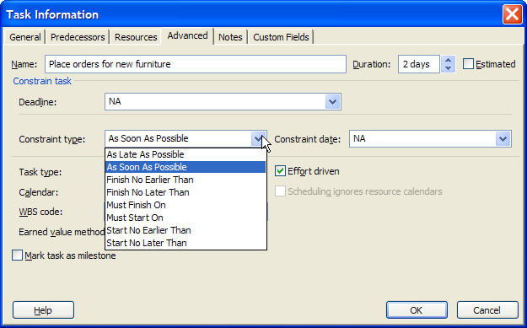  
   
To remove a task constraint:

* Double click on a task to open the Task Information dialog box
* Click **Advanced** tab
* Click **Down Arrow** to the right of the constraint title and select **As soon as possible**
* Click **OK**

## Actions That Create Automatic Constraints



The project manager will manually create constraints when entering a constraint type and date for a task. Constraints can be created in other ways as well.

**NOTE:** *Automatic* *Constraints apply only when using Automatic Scheduling mode.*

If a Start date is entered for an Automatically scheduled task, a Start No Earlier Than constraint will be applied to the task. If a finish date is enteres a Finish No Earlier Than constraint will be applied.

In the example below, a finish date was entered in the finish column for task 7. The result is that a “Finish No Earlier Than” constraint was placed on the task. The task will move out to the date entered and a green triangle will be shown in the date field. The constraint is also shown by an indicator in the indicator column. Hover you mouse pointer over the indicator to see the explanation shown below.

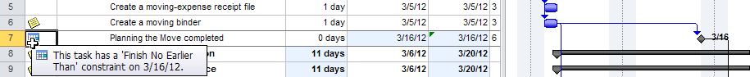

In the next example, a start date has been entered in the start column for task 12. The result is that a “Start No Earlier Than” constraint was created for the task. Creating a constraint will often break relationships between tasks as shown below.

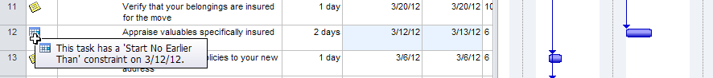

In both cases, the error messages shown below appeared after the date values were entered warning that the constraint created is not advised and the reason why. The error message was triggered by the Planning Wizard.

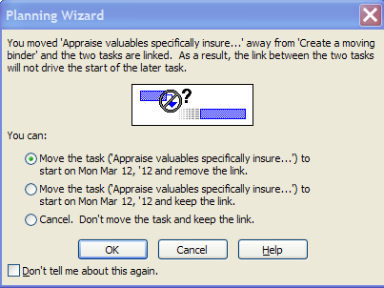

Planning Wizard messages are optional and can be turned off. If they are turned off, you will not be alerted to possible scheduling errors that might be created as a result of creating a constraint or other scheduling issues. The newer Project 2010 user will gain benefit from leaving this option turned on. As the project manager becomes more experienced, it may be turned off.

To change the planning message options for the Planning Wizard:

Click **File 🡪 Options 🡪 Advanced**:

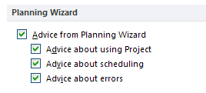

When the Planning Wizard is turned off and a value is entered in the start or finish columns a smart tag will appear and offer the following options:

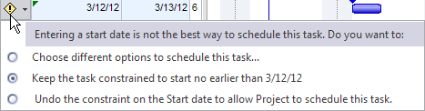

If your scheduling style is to enter dates on each task, it is recommended that you use a manual scheduling approach instead of automatic scheduling. This will allow for tasks to be scheduled to the dates entered and will not be subject to the automatic scheduling engine of the software. If a task is scheduled using manual scheduling, the tasks can be changed to automatic scheduling at any time. There is also an option available that will keep tasks within 1 business day of the manually scheduled date when changed to automatic scheduling.

To set the option to schedule tasks on the nearest working day when changing to Automatically Scheduled mode:

* Click on File 🡪 Options 🡪 Schedule

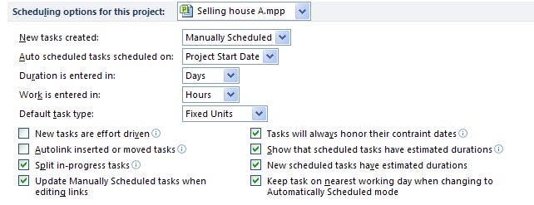

**NOTE:** *Constraints will also be entered as a result of the tracking process which will be discussed in a future module*.

## Effects of Constraints



Constraints may cause errors in the scheduling of a project that are not readily apparent. Look at the example below and see if you can identify the error.

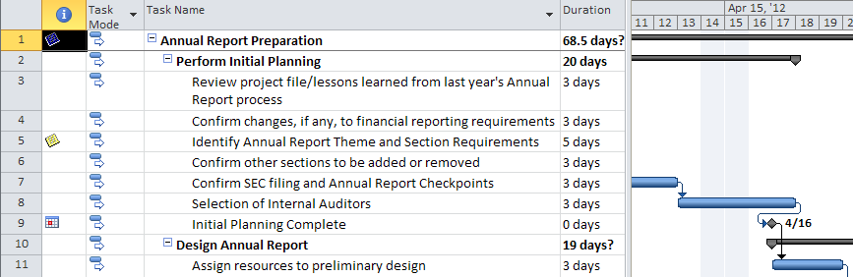

There is an error in the calculation of the date for the task 9 “Initial Planning Complete”. The relationship line after task 8, “Selection of Internal Auditors” flows backwards in time. The reason for this is that task 8 is scheduled to complete on April 17, one day later than the milestone target date of April 16. Tasks that are dependent on task 9 will also be miscalculated.

Monitoring for errors of this type in the schedule is important. In the diagram below, the Total Slack column has been inserted into the table view. One of the uses of the Total Slack column is it can help monitor when task scheduling issues arise. Large positive total slack values might be an indication that dependencies have not been assigned to the task. If the task has negative total slack values, check to see if the task has a constraint.

**TIP:** *Think about the Total Slack column as your checkbook. Positive numbers are good and negative numbers are bad.*

**To add Total Slack column to the view:**

* Right click on the column heading to the right of where you want to insert the column
* Click on Insert Column
* Click on the T on the keyboard
* Click on “Total Slack”

In the example below, the Total Slack column shows -1 day of slack for tasks 1-9. This negative slack is caused by the constraint and resulting error on task 9.

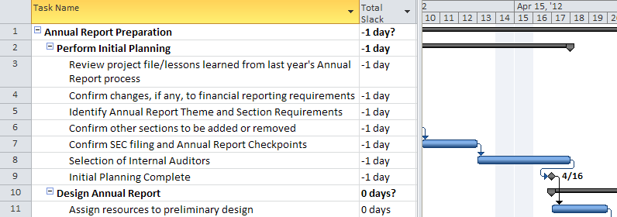

Without the indicator column at the left, it is not evident that there is a constraint on the task. Because of this, it is good practice to insert the indicator column in tables when necessary. Below is the same view with the indicator column added to the table.

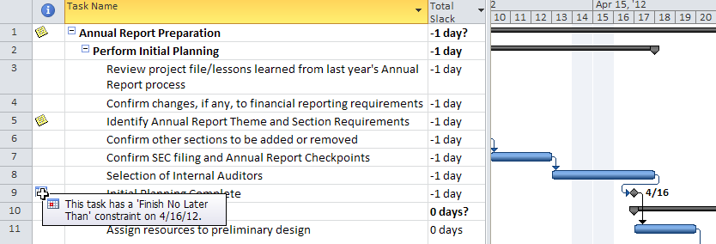

**Best Practices:**

* Constraints are to be used sparingly.
* Do not enter a constraint based on a random target date. All constraints should have a purpose and a reason why they are created.
* If you feel you must use constraints or enter start or finish dates for most of your tasks, manual scheduling might be your scheduling style.
* Keep the Total Slack column handy and watch for the negative values.
* Negative total slack values are indicators of errors in the schedule. They should be resolved before the schedule is approved.

## Practice: Working with Task Constraints



*The Practice page is where you write detailed instructions for completing work listed as Exercises.*

*Type the Exercise Title and write a brief summary what the student will be doing in the exercise. Then list your ideas what they will be doing.*

*SAMPLE*

*In this practice you will create a Project Server Authentication profile and then configure the local cache settings in Project Professional 2007.*

*Exercise 1: Create Project Server Authentication Profile*

*In this exercise you will create Project Server authentication profile to connect to the Project Web Access site.*

Perform the following exercise on the PS07 virtual machine.

1. *From the* ***Start*** *menu, click* ***All Programs*** *🡪* ***Microsoft Office*** *🡪* ***Microsoft Office Tools*** *and click* ***Microsoft Office Project Server 2007 Accounts****.*
2. *In the* ***Project Server Accounts*** *dialog box, click* ***Add****.*
3. *In the* ***Account Properties*** *dialog box, and complete the following settings and click* ***OK****.*

|  |  |
| --- | --- |
| *Setting* | *Perform the following:* |
|  | |
| *Account Name* | *Type* ***Project Server*** |
| *Project Server URL* | *Type* ***<http://epm/pwa>*** |
| *When connecting* | *Select* ***Use Windows user account*** |
| *Set as default account* | *Select check box* |

# Lesson 2: Advanced Task Management



Refining the schedule and fine tuning the scheduling of tasks will help resolve some scheduling issues. Schedules need to remain as flexible as possible. Using the advanced features below will help aid the scheduler in maintaining flexibility as well as offering different ways of analyzing problems within the schedule.

In this Lesson we will discuss:

1. Task Deadlines
2. Using the Task Inspector
3. Using Task Form Views
4. Task Notes
5. Splitting Tasks
6. Changing the start date of the project

## Task Deadlines



Task deadlines are not part of the scheduling of Project 2010 and are treated differently by the software. Deadlines become an objective or a goal for a task. The scheduling of tasks with deadlines will not stop tasks from moving forward the way that other date constraints will. Deadlines enable the user to avoid some of the scheduling errors discussed in the previous lesson. Using deadlines gives the project manager a helpful way of marking target goals within a project schedule and receiving an alert when a deadline is exceeded.

**To set a deadline:**

1. Double click on a task to open the Task Information box
2. Click **Advanced** tab
3. Enter a Deadline date
4. Click **OK**

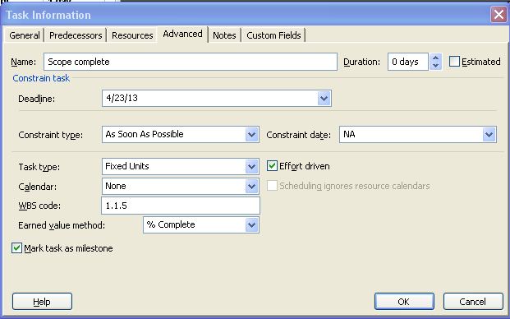

A deadline of April 23, 2013 has been assigned to the “Scope Complete” task below. The deadline is represented by the green arrow on the Gantt Chart and does not appear in the Indicator column.

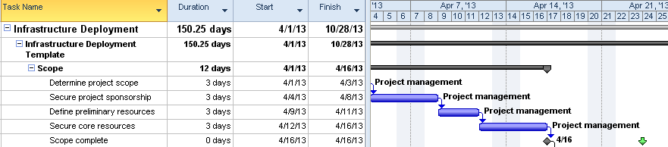

During project execution and tracking of the schedule, tasks will move forward in time. If a task with a deadline moves beyond the deadline arrow, the task will be considered late. Below is an example of the warning that will appear in the Indicator column if a deadline is not met. Notice the red diamond in the indicator column explaining that the task date has exceeded the deadline date.

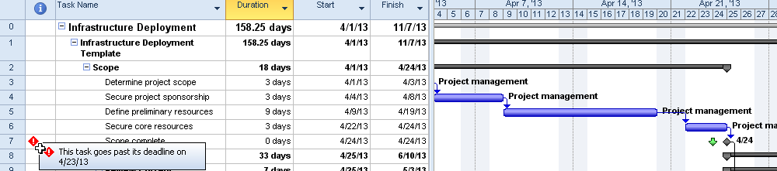

Another indicator to watch would be the Total Slack column. A negative value indicates that tasks are late and have missed or exceeded the deadline. The negative value indicates how many days the deadline was missed by. It is also an indicator of the amount of recovery time required to get the project back on track.

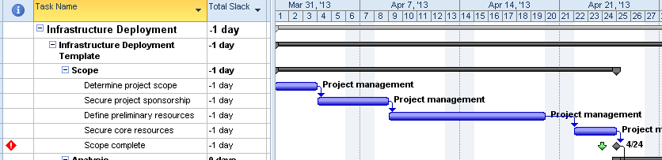

Unlike constraints, deadlines are not part of the schedule calculation but are more of a visual indicator giving you flags when deadline targets are missed.

**NOTE:** Deadlines can be used in both manual or automatic scheduling mode.

**Best Practices:**

* Substitute deadlines for constraints when possible.
* Place deadlines on milestones to help manage short term goals. As long as the deadlines stay on the left side of the milestones, you are doing well.
* When presenting high-level management reports, it is easy to see how the milestone is positioned in relationship to the deadline. It will be easy to measure how the plan is comparing to short-term goals.
* If a deadline date has been exceeded, check the Total Slack column to see how much time needs to be made up to get back on schedule.
* The default formatting for a deadline is a framed green arrow which is hard to see. Change for formatting to a solid green arrow for better visability. Changes to Gantt Charts are unique to a Gantt Chart. Changing the formatting on one chart will not affect other Gantt Charts.

To change the formatting for the deadline indicator on a Gantt Chart:

* Right click on the Gantt Chart area
* Select the Bar Styles option
* Scroll down in the top section until the Deadline line (it is the last line) – click on Deadline
* In the bottom section on the left select the pull down arrow for type
* Select Solid
* Click OK to close the box

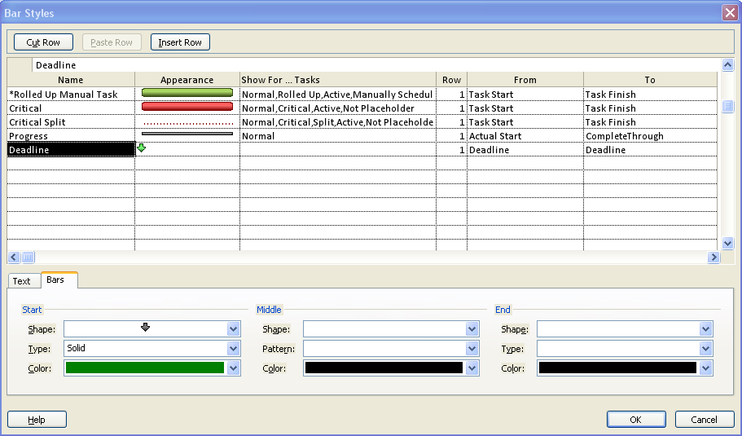

## Using the Task Inspector



Task Inspector is new to Project 2010 and replaces Task Drivers in Project 2007. The purpose of Task Inspector is to analyze and assist in resolving scheduling issues.

Manual scheduling is very susceptible to scheduling errors because of its free form abilities. The errors shown below were a result of scheduling in Manual Scheduling mode. Task Inspector is also very effective in resolving scheduling issues for automatically scheduled tasks. The information in the Task Inspector will change based on the data in a task it is inspecting and the scheduling mode of the task.

Tasks should be inspected if there are scheduling issues or if more information is needed regarding scheduling influences for a task. Below is a list of some of the indicators to watch out for concerning scheduling issues. Some of these concerns were mentioned in the last course module.

* Red squiggles beneath a date in the Start or Finish fields
* Dots around Gantt bars
* Red bar underneath a summary task means that the detail tasks will take longer than what is planned for a summary group

In the example below the task “Determine the best method of moving” is scheduled to start on April 25, which is1 day after the scheduled completion for the summary task ‘Planning the Move”. Note the red squiggles under the date for the “Determine the best method of moving” task and the longer line under the summary task and the dots around the Gantt bar for the task. This error also affects the finish date of the milestone which ends sooner than the detail work of the summary task grouping.

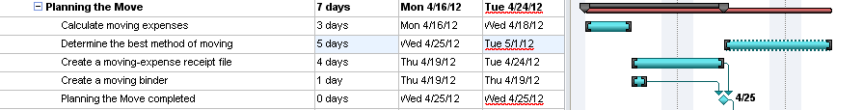

When these problems arise, attempts should be made to resolve the issues. Task Inspector will help resolve some of the problems:

**To activate Task Inspector:**

* Right click the red squiggle in the finish date column
* Select **Fix in Task Inspector, Respect Links, Switch Task to Auto Schedule** or **Ignore Problems for this Task**   
    
  OR
* Click on the task
* Click on Task 🡪 Inspect
* The following choices are returned:

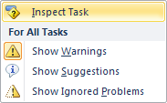

The Task Inspector window will launch to the left of the view and the task number with the error will appear highlighted in yellow. Below is a view of the Task Inspector pane for this situation. The pane information will change depending on the errors for the task, the scheduling mode, information influencing the task and solutions available.

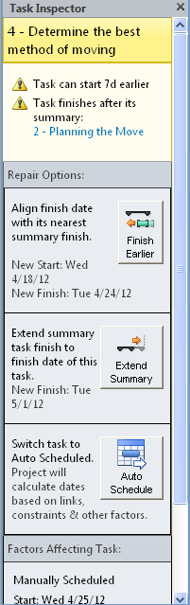

Repair options will vary on a per task basis depending on task information available. The scheduler must determine the best solution for resolving scheduling issues. The lower portion of the Task Inspector lists factors influencing the error.

There is always the option to ignore the errors and allow them to remain in the schedule. At the bottom of the Task Inspector pane is an option to turn off future scheduling warnings for a specific task. If selected, the red squiggles and dots around the Gantt bars for error indication will no longer be visible when issues arise.

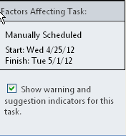

To close the Task Inspector, click the “X” in the upper right corner of the Task Inspector window.



## Using Task Form Views



Task form views are very helpful in putting more information in front of the project scheduler and enabling them to make better decisions. The Gantt Chart and task tables are enabling the viewer to see only Task data. Adding the Task Form view will display resource and assignment data as well.

There are 2 views of Task form information:

* Task Form
* Task Detail Form

The Task Form and Task Detail Forms are very similar. They contain the same information in the lower section of the view. However, Task Detail form contains more data in the header information than the Task Form. Once the form is open, lower section of the form contains 8 sub views which provide different ways of looking at data for flexibility. Even though the Task Form may be shown as a stand alone view it is typically shown as part of a split screen view. One of the most popular split view combinations is showing the Gantt Chart view in the top pane and the Task Form in the bottom pane.

To show the Gantt Chart view in the toppane and the Task Form in the bottom pane of a split screen:

* Click on Task 🡪 Gantt Chart
* In the lower right corner just below the down arrow is a small bar. Double click on the bar 

The result will be the split screen below:

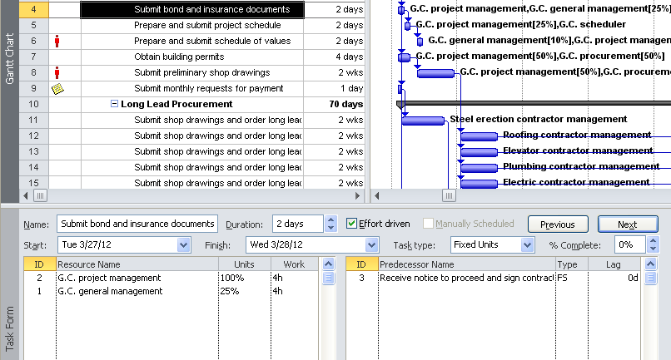

The default option of Resources and Predecessors appears in the Task Form on the bottom. Right click in the bottom pane and you will be offered 8 different choices for different views which will show data in different ways. The available choices are

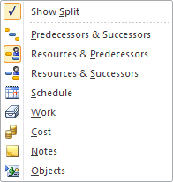

Click in the bottom pane and the pane becomes active. Any changes that are made in the bottom pane are updated to the schedule. When a change is entered in the bottom pane, the button “Previous” changes its name to “OK” which will function as the enter key. Changes will not be updated until the “OK” button has been clicked. In the example below, 2 days of lag was added to the “Define preliminary resources” task. As a result the “Previous” button has changed to “OK”.

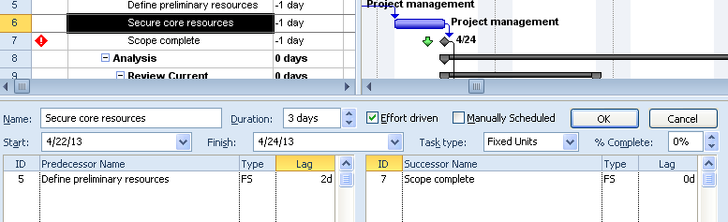

The Task Detail form contains additional information in the header which is helpful during project management and tracking. Its purpose is to put more information in front of the reader to aid in making decisions easier.

**To view the Task Detail Form from the Gantt Chart view:**

* Click on View 🡪 Details

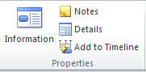

The Task Details Form header is shown below:

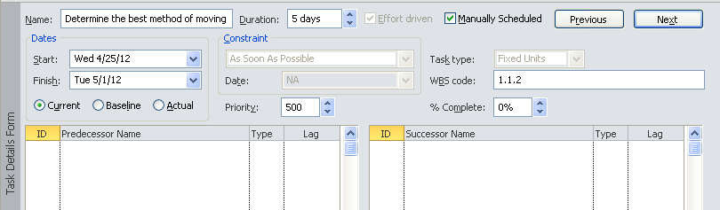

In addition to the information you see above, right clicking in the lower section of the view will reveal the same view options as seen in the Task Form above.

## Adding Notes to Tasks



Each task has a freeform notes field. This field has no character length limitations, allowing for very detailed task notations. The notes field may contain several types of information such as objects, hyperlinks, bulleted lists, etc. Notes may be printed on reports, exported to Excel and may be used as needed throughout the life of the project schedule.

To enter a task note:

* Double click on a task column to show the Task Information dialog box
* Click the **Notes** tab  
    
  OR
* Click on a task column while in the Gantt Chart
* Click **Task 🡪 Notes**

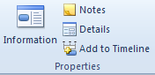

The notes view for a task is shown below:

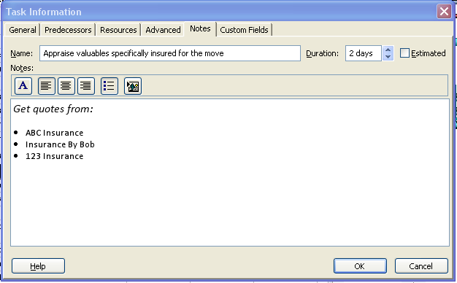

The Indicator column provides a visual indicator that a task note exists. Hovering the pointer over the icon will display the first several characters of the note to give the reader an idea of its content.

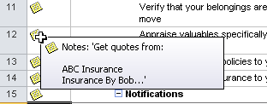

Notes can be invaluable and should be used during the planning and execution of the project. After the project is completed and a post-project review is conducted, task note information will help in recalling details of what occurred during the performance of tasks.

**Best Practice:** Although the software allows users to insert images, documents and other objects and files into the notes, users should avoid doing so as it will significantly increase the file size. It is better to insert references or links to where the user can find associated and relevant files.

## Applying Task Calendars



There will be times when a task must occur within a unique timeframe and outside of the project calendar parameters. In order to accommodate such instances, users can create a distinctive calendar that can be assigned to a task. In doing so the task will be scheduled in the unique timeframe and not affect the scheduling of the entire project.

Below are some examples of when a task calendar would be used:

* Testing at a bank can only occur after the bank is closed 9pm to 6 am
* A weekend cut over of a software package or upgrade
* Testing of a product that requires a 24/7 test
* A task that must occur on second shift
* Task applied to an resource in an alternate time zone

The first step in using task calendars is creating the calendar using the same process described in Module 2 to create a base calendar. After the calendar is created, it then maybe applied to task. The resources assigned to the task will also be required to work in the unique timeframe. There is an option to ignore the resource calendars and allow the scheduling of the resources to be directed by the task calendar for the specific task only.

To assign a calendar to a task:

* Double click on the task to open the Task Information dialog box
* Click the **Advanced** tab
* Click the down arrow next the Calendar option to view the list of calendars that may be assigned as task calendars. Select the appropriate calendar.
* If the “Scheduling will ignore resource calendars” option is needed – check the box
* Click OK to close the box.

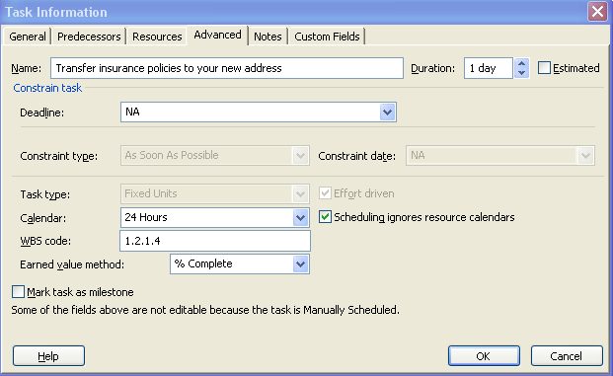

A visual indicator will appear in the Indicator column the Gantt chart view. 

**NOTE:**  Task calendars may only be applied to automatically scheduled tasks or manually scheduled tasks. When Task Inspector is opened, the task calendar that was used will be noted.

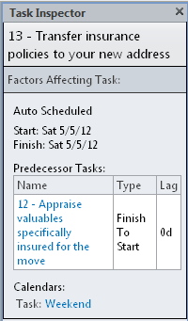

## Splitting Tasks



There will be times during project scheduling that will require an interruption of work for a particular task. For example when planning a task, some of the work will occur on Monday and the remainder will occur on Monday the following week. In this situation two tasks could be entered or creating a split task would also work. Split tasks are designed for scheduling tasks that start then stop and start again.

**When to use split tasks:**

* When the work of a long task is required to work around other tasks. Some of the work would be done before a hard date and the remaining portion of the work would be scheduled after the hard date.
* Splits tasks may be used to help even out the resource work load
* 100% of the work for a task is not required to be performed without interruption and could be broken up over time.

**To split a task:**

* Click on Task 🡪 Gantt chart view
* Click on the split task icon Task 🡪 Split task 
* Hover the split task mouse pointer over the Gantt bar of the task to be split.  
   The screen below will show the information box that will appear.
* As the mouse pointer is dragged the length of the Gantt bar, the date will change in the box. Clicking the mouse pointer will split the task and leave a gap between tasks.

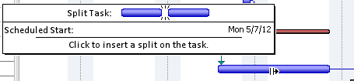

If the schedule has used “day” durations of tasks as the default scheduling increment, the gap in the split task will advance in 1 day increments or 1 week increments if “weeks” was used. A split task is shown in the view below.

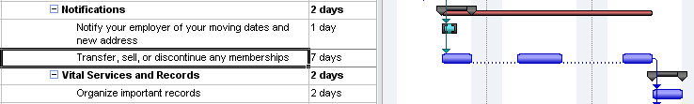

The dots between the sections of the task are the split task indicators showing that the task has been split. The individual parts may be dragged back and forth as necessary to achieve timeframes that will work best for the task. Dragging the pieces back together to eliminate the split status for the ask.

There are a few rules, however that you should be aware of when working with split tasks:

* When a task is split, it is still one task and will be treated as such.
* Relationships will be applied to the beginning and ending of the entire split tasks only and not to the individual pieces. The individual parts are not separate tasks and cannot have discrete relationships.
* When resources are assigned, the work will be distributed over the total task duration and task as a whole.
* Constraints are applied to the start or the finish of the entire task and cannot be applied to the individual parts.
* The parts of the task may be dragged back together when needed.
* Tasks may be split multiple times.
* Splitting will refine the workload and the duration of the task.

There is an option to turn off the viewing of split tasks. The option may be turned on or off as necessary. Below is an example of a two day task which has been split. The work is now planned to be completed in three days.



To turn off the option to view split tasks:

* Click on Task 🡪 Gantt Chart
* Click on Format 🡪 Layout
* Remove the check mark from the Show bar splits option
* Click OK to close the box

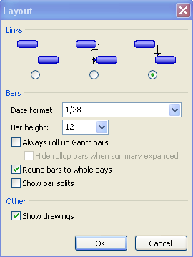

Below is the same task with the task with the option to show the split turned off. Notice that the length of the task did not change but the split task indicators are concealed.



NOTE: Split bars will occur during the tracking process as actual work is updated to tasks

## Changing the Start Date of a Project



Typically a project start date might change between the time the project is planned and the project actually starts. There are several methods available to change the project start date. It is important that the tasks are re-scheduled to adjust to the new start date.

The easiest way to change the project start date is use the Project Information box. Changing the start date using this method will move all tasks without entered dates or constraints to be rescheduled as of the new start date.

**To change a project start date:**

* Project 🡪 Project Information
* Enter new start date
* Click OK to close the box

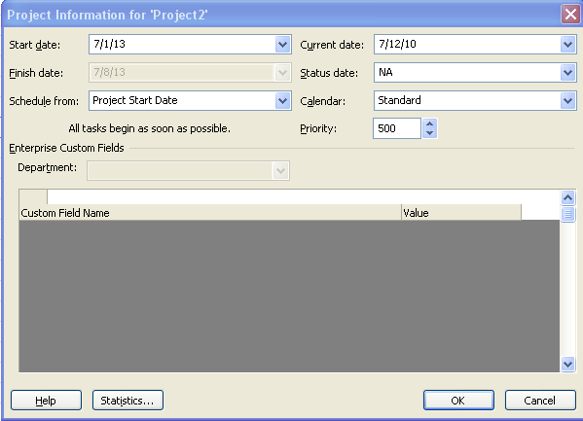

Changing the project start date will not reschedule tasks which have entered dates or constraints. Project 2010 provides a function called *Move Project* which will move all of the tasks to the new project start date. When tasks with constraints are moved using this function, the constraint dates will be adjusted based on the new project start date.

For example: if a task has a constraint 3 months from the start date of the project and the project start date is moved 6 months the constraint date will be re-scheduled 3 months from the new project start date.

The *Move Project* function also has an option to move project deadlines. If this option is not selected, the Deadlines will remain at the orignial dates and will need to be udpated manually.

**To the project start date and move tasks with dates to a new timeframe:**

* Click **Project 🡪 Move Project**
* Enter the new date and click **OK**

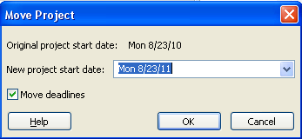

## Practice: Working with Advanced Tasks



*The Practice page is where you write detailed instructions for completing work listed as Exercises.*

*Type the Exercise Title and write a brief summary what the student will be doing in the exercise. Then list your ideas what they will be doing.*

*SAMPLE*

*In this practice you will create a Project Server Authentication profile and then configure the local cache settings in Project Professional 2007.*

*Exercise 1: Create Project Server Authentication Profile*

*In this exercise you will create Project Server authentication profile to connect to the Project Web Access site.*

Perform the following exercise on the PS07 virtual machine.

1. *From the* ***Start*** *menu, click* ***All Programs*** *🡪* ***Microsoft Office*** *🡪* ***Microsoft Office Tools*** *and click* ***Microsoft Office Project Server 2007 Accounts****.*
2. *In the* ***Project Server Accounts*** *dialog box, click* ***Add****.*
3. *In the* ***Account Properties*** *dialog box, and complete the following settings and click* ***OK****.*

|  |  |
| --- | --- |
| *Setting* | *Perform the following:* |
|  | |
| *Account Name* | *Type* ***Project Server*** |
| *Project Server URL* | *Type* ***http://epm/pwa*** |
| *When connecting* | *Select* ***Use Windows user account*** |
| *Set as default account* | *Select check box* |

# Summary



Once created, the project schedule must be refined and adjusted to bring the schedule into a realistic and workable timeline. This module described some of the tools in Project 2010 to help tailor a project schedule to your needs.

In this module we discussed:

* Project constraints
* Project deadlines
* Notes
* Task Inspector
* Task Calendars
* Task form views
* Split tasks
* Changing a project start date